Assignment 3
  - Deadline: Day 29/04/2017 @ 23:59
[Total Mark for this Assignment is 4]

Computer Network
IT 210

Instructions:
- This Assignment must be submitted on Blackboard via the allocated folder.
- Email submission will not be accepted.
- You are advised to make your work clear and well-presented, marks may be reduced for poor presentation.
- You MUST show all your work.
- Late submission will result in ZERO marks being awarded.
- Identical copy from students or other resources will result in ZERO marks for all involved students.
- Convert this Assignment to PDF just before submission.
Student Details:
Name: ###  CRN: ### |  | ID: ###

Question One
1.2 Marks
Learning Outcome(s):
Understand the notation of the classless IPv4 address.

Be able to find different information (like first address, and range of addresses) from a given classless IPv4 address.

Q 1. Assume an organization has the classless address 15.25.16.8/17, then find the following:
- The first address
- The last address
- The total number of addresses
- The network address
- Does the address 15.25.15.127 belongs to this address space?
- Does the address 15.25.128.0 belongs to this address space?

Question Two
1.3 Marks
Learning Outcome(s):
To understand the IPv4 datagram format and the purpose of fragmentation in a datagram.

Q2.
a) In an IPv4 packet, the value of HLEN is (1010)₂ , and the value of the total length field is (005A)₁₆. How many bytes of data are being carried by this packet?
b) A packet has arrived in which the offset value is 175, the value of HLEN is 10, and the value of the total length field is 100. What are the numbers of the first byte and the last byte?

Question Three
0.5 Marks
Learning Outcome(s):
Understand the virtual circuit approach of packet-switched networks.

Q3. What are the three phases needed in virtual circuit approach? What type of packets is used in each phase?

Question Four
1 Mark
Learning Outcome(s):
Understand the working of routing protocols.

Q 4. See the network shown below. The figure consists of four automatous systems (ASs) each running RIP as an internal routing protocol. Moreover, iBGP and eBGP are used as border gateway protocols. AS4 is connected to an external network called “x.” By carefully examining the figure below, answer the following questions:
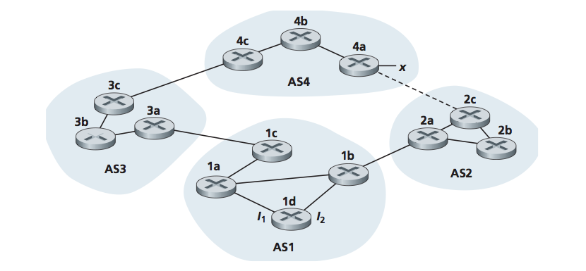
- Which protocol is used to tell router 1b about network x? iBGP, eBGP, RIP or OSPF?
- Which protocol is used to tell router 2b about network x?
- Which protocol is used to tell router 3b about network x?
- Which protocol is used to tell router 1c about network x?

